Navrachana University Vadodara

School: Business & Law
Program: BBALLB
Title of the Event: IPR Symposium
Date: 29/4/23 – 29/4/23

SUMMARY REPORT OF THE ACTIVITY CONDUCTED

CATEGORY | seminar
NAME OF ACTIVITY | IPR SYMPOSIUM
NAME OF AGENCIES/CONSULTANT CONTACTED | Dr. Narottam Sahoo  Ms. Ragini Shah  Ms. Satya S Pogaru  Ms. Meera Marthak
EVENT ORGANISED FOR | STUDENTS, ACADEMICIANS, RESEARCHERS
ORGANISING UNIT/ AGENCY | LAW DEPARTMENT, SCHOOL OF BUSINESS AND LAW, NUV
NAME OF SCHEME | IPR SYMPOSIUM
YEAR OF ACTIVITY | 2023
MODE OF PROGRAM | OFFLINE
VENUE | NAVRACHANA UNIVERSITY
DIGNITORIES PRESENT AT INAUGURAL | 1. DR. HITESH BHATIA – DEAN, SBL, NUV  2.DR. SUJATHA PATIL – PRINCIPAL , LAW DEPARTMENT, NUV  2. MRS. CHANDRIKA TEWATIA RAJ – ASST. PROFESSOR, NUV  3. MS. MADHURA THOMBRE- ASST. PROFESSOR, NUV  4. MS. STELLA JOICE – ASST. PROFESSOR, NUV  5. MS. NIDHI JAIN – ASST. PROFFESOR, NUV  6. MR. VIDHYAMAN – ASST. PROFESSOR, NUV
TOTAL PARTICIPANTS | 80
FEES PER PARTICIPANT | NA
TOTAL FEES RECIEVED IF ANY | NA
INCOME FROM OTHER RESOURCES IF ANY | NA
TOTAL INCOME | NA
TOTAL EXPENDITURE IF ANY | NA

Navrachana University Vadodara

School: Business & Law
Program: BBALLB
Title of the Event: IPR Symposium
Date: 29/4/23 – 29/4/23

Participants
22000193 | ARYA PANDEY
22000194 | DARSHITA JOSHI
22000197 | HELI PATEL
22000198 | HET PARDESHI
22000199 | HIMANSHU KUMAWAT
22000200 | KRISHNA PATEL
22000201 | MAHEK BARADIYA
22000202 | MANSI TIWARI
22000204 | PRINCY SINGH
22000206 | SAMBHAV SHAH
22000207 | SHARAD KUMAR
22000208 | YASHVI SONI
22000209 | GEETHA RAIKA
22000554 | PATEL VARDA
22000671 | DHAIRYA SORATHIA
22000679 | SANJAI SAI
22000681 | JASH SHAH
22000701 | ANSH JAIN
22000717 | JAY SONI
22000759 | EZRA PARMAR
22000826 | NIDDHI AGRAWAL
21132001 | OM AMIN
21132002 | SHIVAM BHATT
21132003 | ANIKA MANAKTALA
21132004 | PRATHAM PAREKH
21132005 | SOMNATH SAHA
21132006 | HARSH SOLANKI
21132009 | KOMAL AGARWAL
21132010 | MUSKAN TILOKANI
21132013 | KHUSHBU GYANCHANDANI
20132001 | ANANYA GARG
20132002 | DHRASTEE PATEL
20132003 | DHRUV THAKKAR
20132004 | DISHA SHIVNANI
20132005 | HET JOSHI
20132008 | NIRAL CHOUDHARY
20132009 | NISH PAREKH
20132010 | RANVEERSINGH WHALA
20132011 | ROHAN GUPTA
20132012 | VANSHIKA AGRAWAL
20132013 | DIKSHA DUTT
20132014 | PRIYA PARMAR
20132015 | ADITYA SHARMA
20132017 | HARIDAS VENKATESH
20132018 | PRANAV VERMA
20132019 | ARYAN KAPADIA
20132020 | TAIBA MAKRANI
20132021 | DHRUV VAKIL
19132003 | KRUPA CHAHUHAN
19132004 | PRATIKSHA THAKUR
19132005 | RITIK BRAHMBHATT
19132009 | OMPRAKASH GUPTA
18132001 | TARUSH BHANDARI
18132002 | MEET DHARSANDIA
18132003 | DIVYA MAINI
18132004 | JEMINI PATEL
18132005 | SHREYA SHARMA
18132006 | BHUMIKA KHANDELWAL
18132007 | PRANJAUL JHAVERI
18132009 | DARSH SHAH
18132010 | SHABBIR LIMKHEDAWALA
18132014 | MIT THAKKAR
18132016 | HRUTVIK THAKOR
18132018 | NIMITT PORECHA

Navrachana University Vadodara

School: Business & Law
Program: BBALLB
Title of the Event: IPR Symposium
Date: 19/1/23 – 19/1/23

DETAILS OF EXPERT INVITED
SR.NO | NAME | DESIGNATION | NAME OF ORGANISATION | TOPIC OF LECTURE
1. | Dr. Narottam Sahoo | Advisor & Member Secretary, Gujarat Council on Science & Technology, Gujarat Council on Science & Technology (GUJCOST), Government of Gujarat. | GUJCOST | Introduction to Patent
2. | Ms. Ragini Shah | Lead Partner IP Transactions and Start-up Solutions, ANM Global Inc. | ANM Global Inc. | Basis of Patent Specification and Drafting
3. | Ms. Satya S Pogaru | Vice- President (Engg. & Software Group) and Patent Agent, Lexpert Consilium LLP, | Lexpert Consilium LLP | PCT, PCT Application
4. | Ms. Meera Marthak | Senior Manager- IPR Department, Alembic Pharmaceutical Ltd, Vadodara | Alembic Pharmaceutical Ltd | Patent Enforcement, Commercialization

5th IPR SYMPOSIUM REPORT
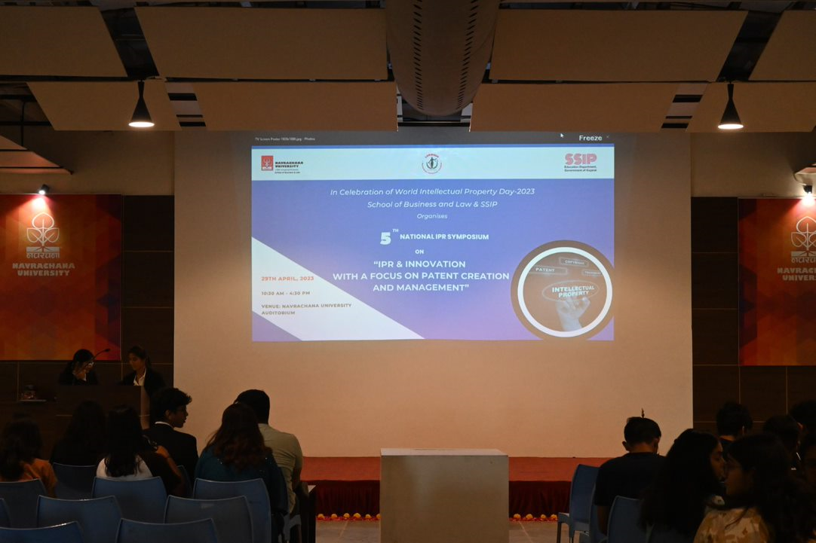
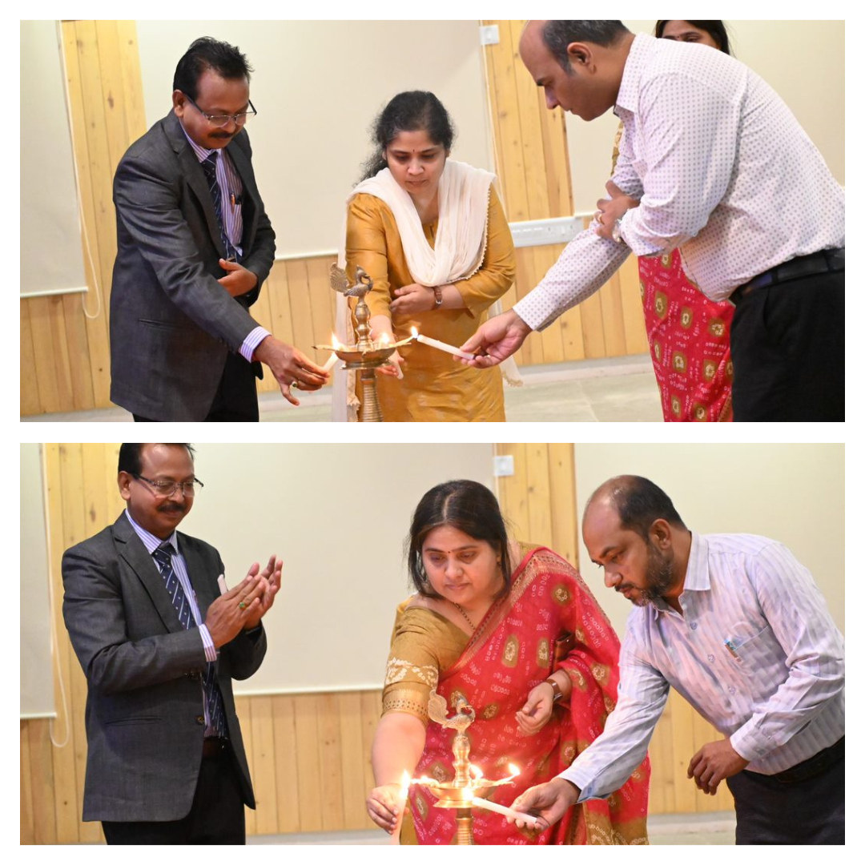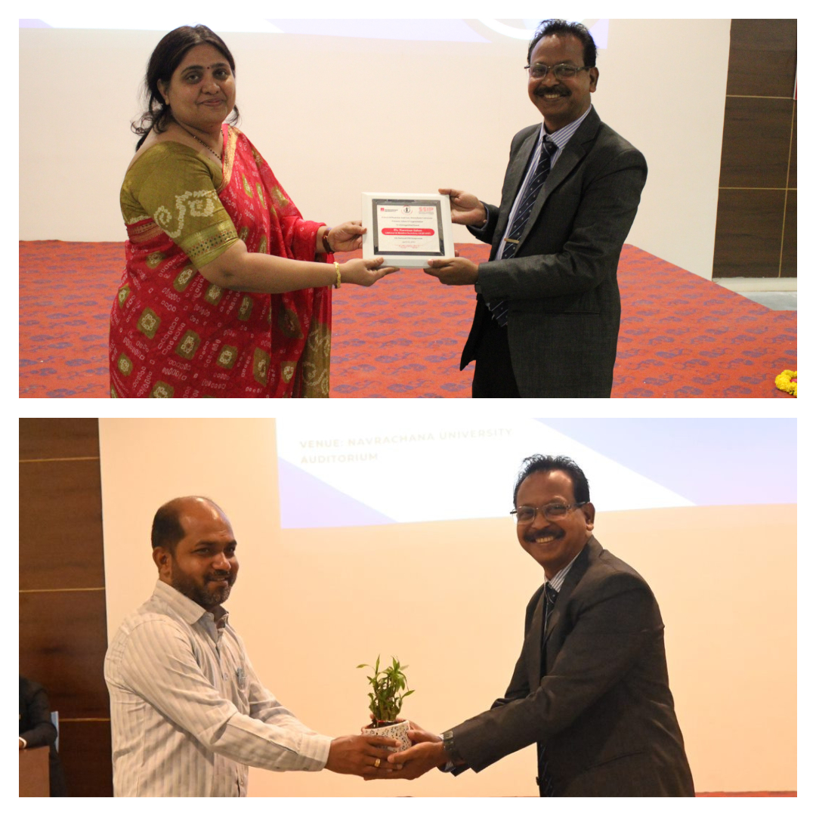
The Law Department of School Of Business And Law [SBL] of the Navrachana University along with SSIP hosted the 5th National IPR Symposium on “IPR and Innovation With a Focus On Patent Creation And Management” in the celebration of World Intellectual Property Day 2023 on 29th April, 2023 at the NUV Auditorium for students, academicians and researchers etc. The symposium was hosted to create awareness about IPR amongst the youth and motivate them to come up with inclusive, affordable innovations. For the symposium, all the students from law from 1st to 5th year showed an active participation, and there were several other participants from other schools of Navrachana and other colleges in the city.
The symposium included hands-on training for patent filing from the renowned and experienced patent agent. The event had four guest speakers,
1. Dr. Narottam Sahoo – Advisor & Member Secretary, Gujarat Council on Science & Technology, Gujarat Council on Science & Technology (GUJCOST), Government of Gujarat.
2. Ms. Ragini Shah – Lead Partner IP Transactions and Start-up Solutions, ANM Global Inc.
3. Ms. Satya S Pogaru – Vice- President (Engg. & Software Group) and Patent Agent, Lexpert Consilium LLP, Ahemdabad.
4. Ms. Meera Marthak – Senior Manager- IPR Department, Alembic Pharmaceutical Ltd, Vadodara
The session started with lightning of the lamp at 10.30 am by the dignatories, followed by opening speech from the dean of SBL, Dr. Hitesh Bhatia. Then, there was a welcome speech by Dr. Sujata Patil, Principal of Law Department.
At 11:01 am, the first speaker of the event Dr. Narottam Sahu took over the event and introduced Patent to the audience and the Patent rights in detail. He gave various in dept information about Patent and Patent rights to make the basics clear for the audience. After, his session, Dr. Sujata Patil felicitated him with a sapling and a momento.
Then Mr. Vidhyaman, Assistant Professor at Law Department, took the hold of the event and spoke to audience about his knowledge about Patent. After his speech, Ms. Madhura Thombre, Assistant Professor at Law Department introduced the second speaker for the day, Ms. Ragini Shah and invited her to share her knowledge with the audience. Ms. Ragini Shah, started her session with a question answer round with the audience and asked several questions related to business and how many in the audience were interested in starting up their own business with some unique idea. She then explained what patent is quickly, and then explained trademark, copyright, design, trade secret. She also informed about the compulsory licensing, given under sec. 84 of Patent Act, and talked about some landmark cases and their judgement. The landmark cases explained by her were: 1. Novartis vs. Union Of India
2. Roche vs. Cipla
She ended her session by taking up doubts and questions from the audience.
Ms. Nidhi Jain, Assistant Professor, Law Department, felicitated her with a sapling and momento.
Then there was lunch break from 12.30 to 1.30pm.
The second session started at 1.30 pm with the 3rd speaker of the event, Satya S Pogaru, vice president engg and software and patent agent, had her session on the basis of patent specification drafting and relevance of patent claims. She introduced herself and introduced the topic she was going to cover: drafting and the applications used for drafting.

The session started with ma'am explaining the Indian Patent System. In India, first patent statue was passed in 1857. The Patents Act came in 1970, and was amended in 1999, 2002, and 2005. The Patents Rule was formed in 2003 and amended in 2005, 2006, 2020 and 2021.
She then explained, Patent. What is Patent? A Patent is an exclusive right granted for an invention, which is a product or a process that provides, in general, a new way of doing something, or offers a new technical solution to a problem. A Patent is an exclusive right granted for an invention.
She explained the three criterion for Patenting:
1. Industrial Use (Useful)
2. Novel (New)
3. Inventive Step (Non Obvious)
She then explained,
- What cannot be Patented?
- ​Discoveries, abstract theory
- Theories or Principles
- ​What not to do before filing a patent application?
- ​Steps in Patent Application Drafting and Filing

Major sections of the patent specification
1. Provisional
- ​Title of invention
- ​Technical field of the invention
- ​Background of the invention
- ​Summary of the invention
- ​Description of the invention
2. Complete
- ​title of the invention
- ​Technical field of invention
- Background of invention
- Summary of invention
- Drawings
- Brief and detailed description of invention
- ​Claims
- Abstract

She then showed us a real Patent of Michael Jackson's Moon Walk. The invention behind the step, which is patented. The three main aspects in filing a patent: Structural aspect, functional aspect and operational aspect.

Anatomy of Patent and Contents
- ​Patent Number
- Data of grant
- US classification codes
- Date of filing
- ​Title
- ​Inventors
- Assignee
- Abstract
- ​References
- Application number

Rights Conferred by the Patent (section 48)
Section 64 Revocation of Patent
Section 10 Contents of Specification
Rule 13 Specifications

Who is interested in your Patent Specification?
- ​Patent Office
- ​Licensee/Assignee
- Court
- Technical Peers
- ​Competitors
- Commercial Players
- General Public

Forms of application

- Ordinary application
- Divisional application
- Convention application
- Patent of addition
- PCT application
Then there was an interactive question answer session with the audience, where ma'am took all the questions the audience had regarding the patent system, and the filing of patent. Some of the questions discussed were:
- Can education process be Patented?
- Utility patent
- Design patent
- ​can one particular patent go into both utility and design patent
- ​How do we make a balance while drafting claim, that is broad and noble.
- ​Tips to crack patent drafting exam
There was felicitation of guest by Ms. Stella Joice, Assistant Professor, Law Department with a sapling and a momento.

The 4th guest for the event was Meera Martahak, who was presented by a sapling by madhura ma'am. She introduced the topic she was going to cover which was 'Patent filing procedure, enforcement and infringement'.
She talked about Filing of Patent Applications, Publication for Application, Request for Examination, Examination, Issues of FER, Response from the applicant.
Later in the session, she informed us about Grant of a Patent, the Renewal Fee, Consideration& Examination of Pre Grant Opposition and discussed PCT in detail. She informed us a PCT Application contains:
- A request
- A description
- One or more claims
- Drawings
- An Abstract
She also informed us about the typical PCT Timeline and the advantages of PCT.
Another aspect that she covered was Patent Infringement, where she explained ‘Violation of a patentee’s right with respect to some invention is known as Patent Infringement.’ Types of Patent Infringement, along with doctrine of equivalence were also discussed.
The last topic covered by her was Patent Enforcement, Laws governing Patent Rights, Different types of orders provided by courts and Patent Commercialization.
Then at the end of her session, Mr. Vidhyaman, Assistant Professor, Law Department, presented her a momento as a token of thanks and appreciation, for giving her valuable time and knowledge with the audience.

The symposium came to an end at 3:48 pm with Vote of thanks by Ms. Niddhi Jain, Assistant Professor, Law Department.

